Simran Shilky

9918103027

F1

**Assignment 2 Solution**

1. # Script to print Hello World

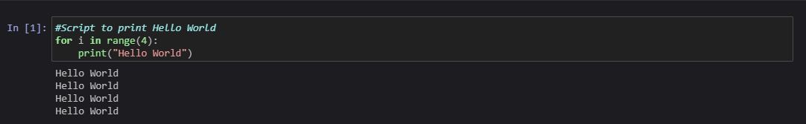

1. # To print a string



1. # To print duplicates

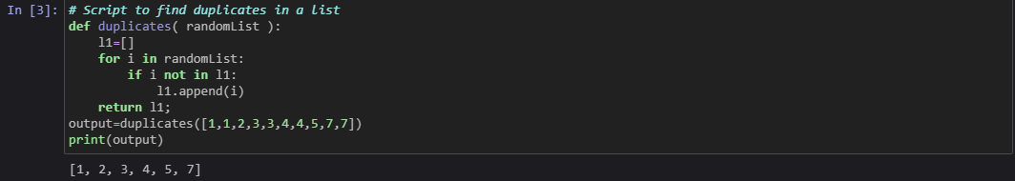

1. # To split a list into a group of a given size

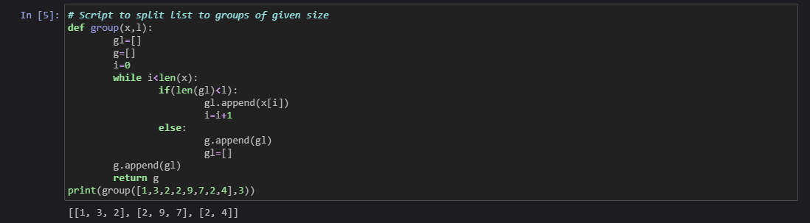

1. # To implement lensort

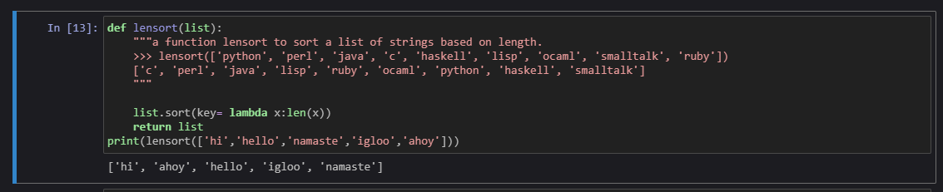

1. # To implement exsort

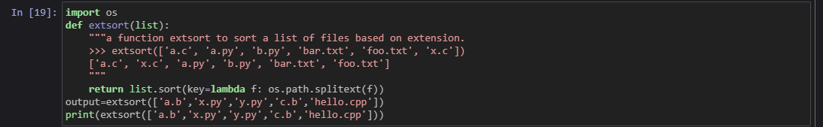

1. # To perform basic file handling

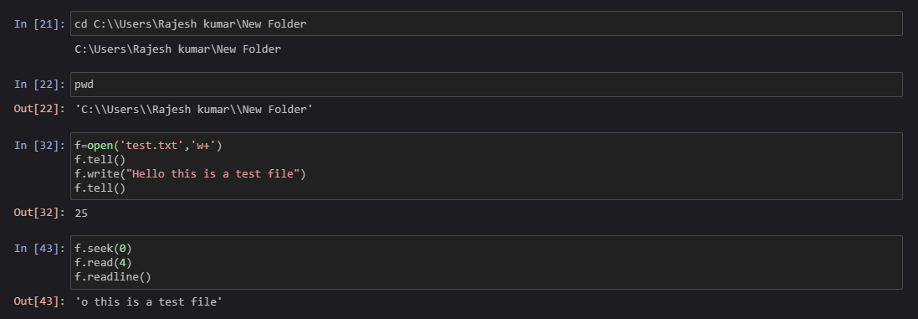

1. # To count words, spaces, and lines of a file

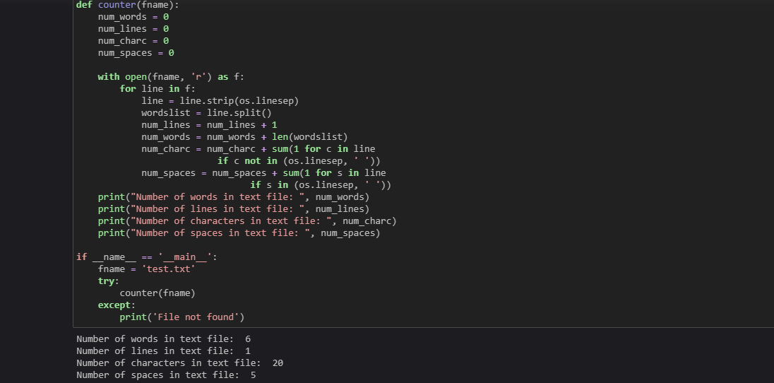

1. # To print lines in reverse order

